**INFOLABZ IT SERVICES PVT. LTD.**

**Internship : Data Science**

**Topics to be covered :** Loading API with React

async function bitcoin(){

mydata = await (await fetch("URL")).json();

}

1. BITCOIN API

* Print bitcoin price in USD

URL : https://api.coindesk.com/v1/bpi/currentprice.json

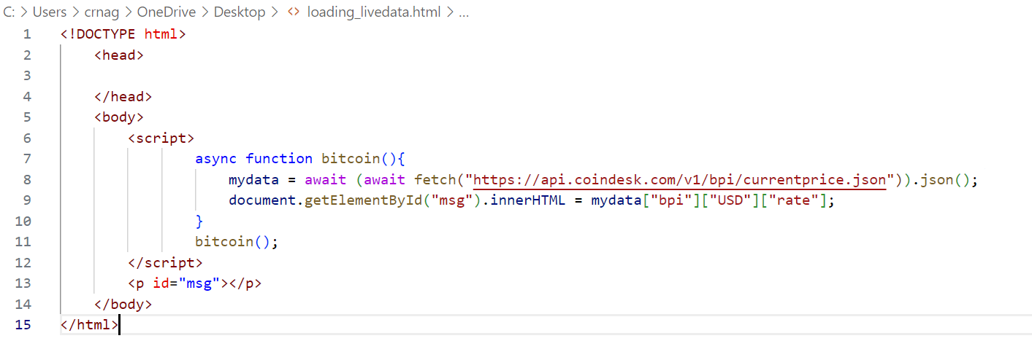

1. **ISRO API**

URL : <https://isro.vercel.app/api/spacecrafts>

Print Data in table ( as give in below format ) from above API.

SPACECRAFT ID | SPACECRAFT NAME

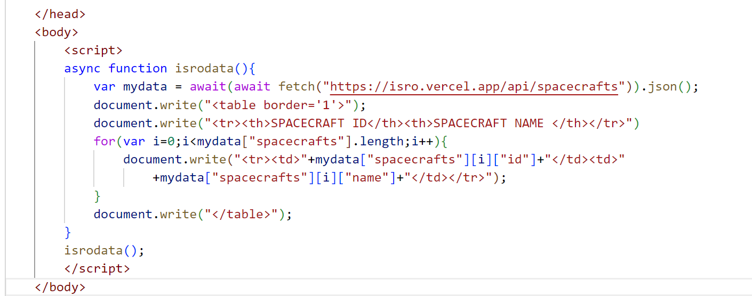

1. **University API**

URL : <http://universities.hipolabs.com/search?country=india>

Print Data in table ( as give in below format ) from above API.

SR NO | UNIVERSITY NAME | WEB PAGE

1. **Covid API**

URL : <https://data.covid19india.org/data.json>

Print Data in table ( as give in below format ) from above API.

SR NO | STATE NAME | TOTAL CONFIRMED | TOTAL RECOVERED | TOTAL DEATHS

1. **Covid API**

URL : <https://data.covid19india.org/data.json>

Print Data in table ( as give in below format ) from above API.

SR NO | DATE | DAILY CONFIRMED | DAILY RECOVERED | DAILY DEATHS | TOTAL CONFIRMED | TOTAL RECOVERED | TOTAL DEATHS